**FILES AND DIRECTORIES**

**LAB # 08**



**Fall 2022**

**CSE302L System Programming Lab**

Submitted by: **Maaz Habib**

Registration No.: **20PWCSE1952**

Class Section: **C**

“On my honor, as student of University of Engineering and Technology, I have neither given nor received unauthorized assistance on this academic work.” Student Signature:

______________

Submitted to:

**Engr. Abdullah Hamid**

Sunday, December 19th, 2022

**Department of Computer Systems Engineering**

**University of Engineering and Technology, Peshawar**

**Task # 01:**

**Implement ls command.**

**Code:**

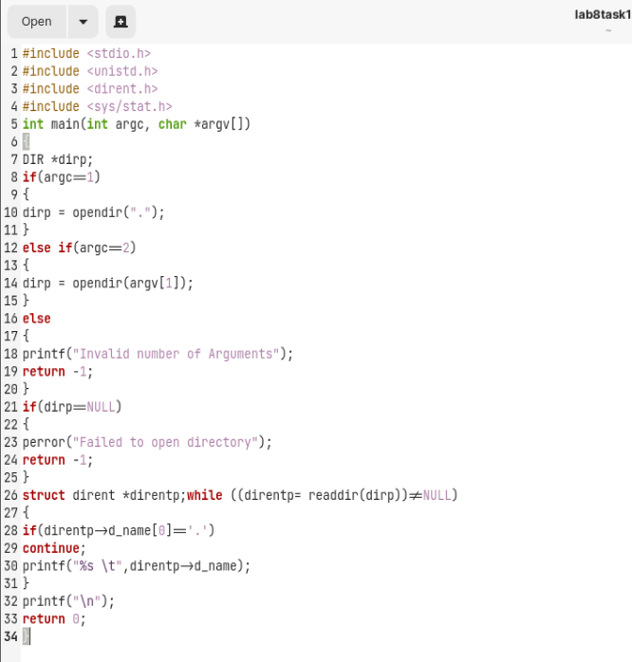

**Output:**

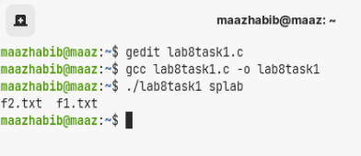

**Task # 02:**

**Implement ls -l command.**

**Code:**

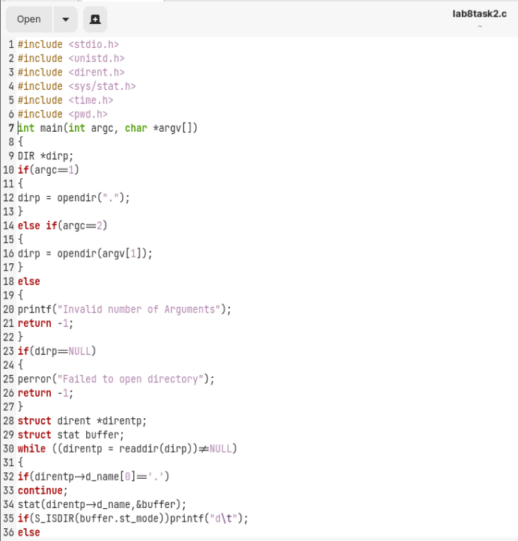

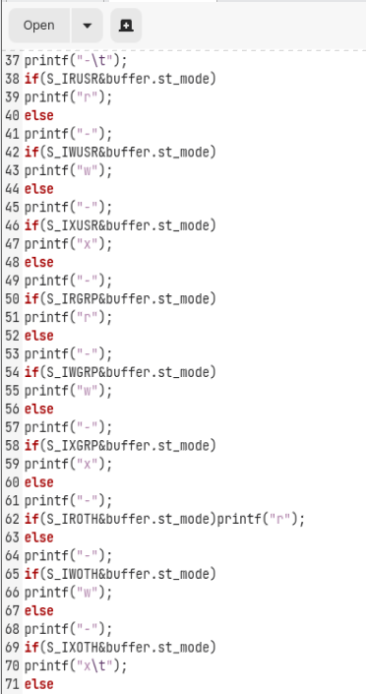

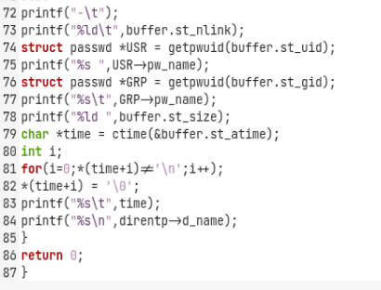

**Output:**

